Государственное учреждение образования « Средняя школа № 21»

План-конспект открытого урока по теме:

“Enjoy Belarus”

проведённого в 6 «Б» классе

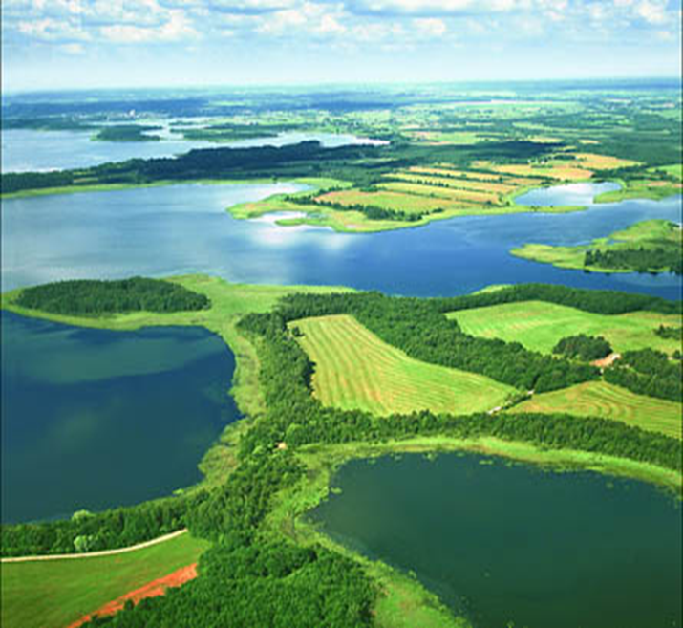

Выполнила:

учитель английского языка

Коновалова И.Н.

Гомель 2016

Тип урока: урок комплексного применения знаний, умений и навыков

Вид урока: урок-путешествие.

Формы работы: индивидуальная, парная, групповая и коллективная.

Используемые методы: коммуникационный, игровой, проблемный.

Цель урока: совершенствование лексических навыков по теме «Беларусь » на уровне свободного высказывания в виде монологической и диалогической речи.

Задачи урока:

- создать условия для систематизации активного и пассивного словаря учащихся по теме;

- содействовать выработке навыков непроизвольного употребления речевых образцов;

- способствовать закреплению употребления Present Perfect и Past Simple

и усвоению знаний о географическом положении и природе Беларуси.

Оборудование урока: ноутбук, мультимедийная приставка, магнитофон.

Дидактическое оснащение урока: УМК «Английский язык» для 6-го класса, раздаточный материал.

Урок английского языка в 6 классе по теме Belarus

Тема урока : Enjoy Belarus

Ход урока :

**ОРГАНИЗАЦИОННО-МОТИВАЦИОННАЯ ЧАСТЬ**

Введение в иноязычное общение. Объявление темы урока

Good morning, pupils. What date is it today? Who is absent today?

Do you like the weather today? Well, today we’ll have an unusual lesson. We’ll go on a trip around our beautiful country. We’ll visit different sightseeings, play games and talk a lot about our land. I hope you’ll enjoy the trip and you’ll enjoy Belarus. And at the end of the lesson I want you to say what you enjoyed most of all during the trip.

First of all let’s choose by what kind of transport we’ll go on a trip around Belarus.

(pictures) What means of travelling do you know?

How can we get to different parts of our country?

Which is the most comfortable?

Which is the most interesting?

I think going by balloon is the best way of travelling for us. Do you agree?

**ОПЕРАЦИОННО-ПОЗНАВАТЕЛЬНАЯ ЧАСТЬ**

1. Актуализация нужных на уроке знаний

To get to a place in a hot-air balloon is not an easy as you think. You need a ticket

I am sure you know a lot about our country. Let’s play a game “ Statistics”. I have prepared some numbers for you, connected with Belarus, you should make up sentences with them. If you do it you will get a ticket and go on a trip around Belarus with me.

207000 – the area of Belarus 3 – colours of the Belarusian flag

10 mln- the population 111 – species of trees in Belarus

6- regions 30 000 – species of animals

1067 – Minsk was founded 305 – species of birds

2 mln – the population of Minsk 20 -25 – summer temperature

Great! All of you get places in the hot-air balloon! Here we go!

While travelling you often ask and answer questions. Let’s repeat question words.

Translate them from Russian into English ( who, what, when, where, whose, why, how many, how much, what time). Work in pairs and choose the correct word.

( Teacher gives an exercise to the pupils)

Choose the correct word.

1. __________ is it? 2. ________ is that radio? My father’s.

a) Who b) Where c) What a) What b) Whose c) When

3. _______ is that girl? My cousin. 4.______ do you go to the shops?

a) Who b)Where c) Whose a) What b) Whose c) When

5.______is the dog? In the garden. 6._______are you late?

a) Whose b) What c) Where a) What b) Who c) Why

7. _______is your sister’s name? 8. _______ does the film start?

a) What b) Who c) Why a) Who b) When c) What

2. Рабата с основным содержанием

a) A blue-eyed country. Usually tourists talk to each other during their journeys, don’t they? Let’s have a talk too. What do you see? Lakes and rivers. How do people call Belarus? Why? How many lakes ( 10 000 – 11 000) are there in our country? How many rivers (20 000) are there in Belarus? What are they?

в) Pripyatsky National Park. A game “Guess”. We are flying over Gomel region. Oh, I see the largest National Park of Belarus . What is it? Right. It’s Pripyatsky National Park. What it is famous for? I see animals and birds but I can’t understand what animals or birds they are. Can you help me?

Animals: bears, wolves, foxes. Lynxes.

Birds: grey crane, black stork, snake-bird, woodpecker, owl, azure tit.

с)Belovezhskaya Pushcha. Работа с текстом. Описание животных с опорой на текст и план.

Let’s continue our trip. We are flying further over Brest region. What is the second place we’ll visit? What do you think? Yes! It’s Belovezhskay Pushcha. Let’s work in groups.

Open your text books and find page 60. Look through the texts 3 and 5.

Describe the animals using the plan.

Describe the European bison and the beaver

1. Place they live

2. Size and colour

3. Food they eat

4. Are they in danger?

5. Some interesting facts

Релаксационная пауза

Let’s have fun. Sing a song “I love Belarus” together with the participant of Eurovision 2011 Anastasiya Vinnikova.

d) Mir and Nesvizh Castles. True or False.

We are over Grodno region and Minsk region. I see 2 beautiful castles. What are they? Yes. Mir and Nesvizh Castles. Let’s play a game “ Fact or fake”. You have two cards: red and green. If you hear a fact show me the green card. If it is fake show me red one and correct.

1. Nesvizh is situated in Grodno region. ( no, in Minsk region)

2. The castle in Nesvizh is older than the castle in Mir. ( no, Nesvizh was built in the 16th century, Mir in the 15th )

3. The Radziwills lived in Nesvizh Castle. (yes)

4. White bricks were used to build the castle of Mir. (no, red)

5. Since 1990 the Castle in Mir has been a museum. (no, since 1992)

6. The castles are famous for their ghosts. (yes)

7. The Black Dame and the Black Nun are the ghosts of Mir Castle. ( no, Nesvizh.

8. The Black Dame is the ghost of Radziwill-Sirotka.( no, Barbara Radziwill)

e) We continue our trip and I want you ask each other questions using Past Simple or Present Perfect. Учащиеся выполняют упражнение, а затем задают друг другу вопросы и отвечают на них.

**РЕФЛЕКСИВНО-ОЦЕНОЧНАЯ ЧАСТЬ**

1. Рефлексия

We have finished our trip. What places have you been to? What did you enjoy most of all . Are you proud of your country? Why?

2. Оценивание работы каждого учащегося, выставление и комментирование отметок. Объяснение домашнего задания.

I enjoyed the trip very much. On one hand I am pleased because I have seen many wonderful places of my country? On the other hand I am happy because you know a lot about our land. It’s great.